The Hand Guide
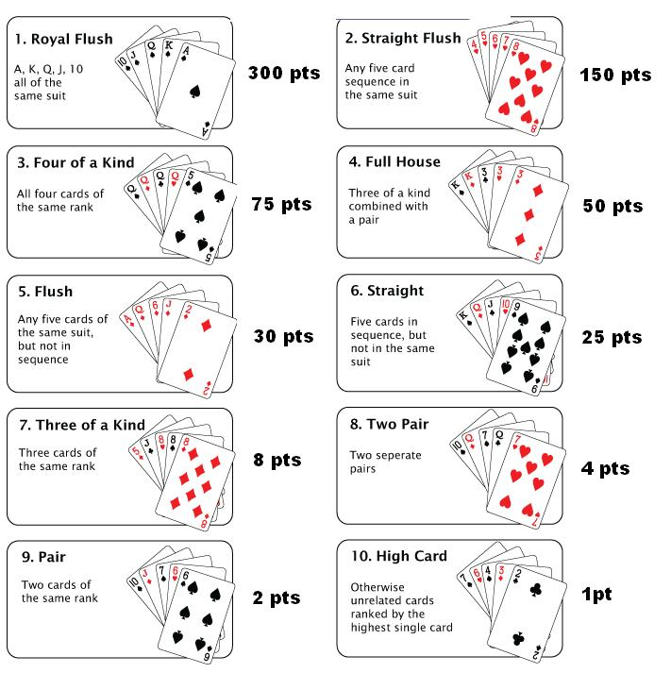
Rules:
- You cannot partner with the same person to form a Starting Hand more than once.
- You cannot change cards with anyone.
- You must approach the Dealer together with your ’partner’.
- If there is a tie for the individual with the most points at the end of the night then there will be a high card draw for the winner.
- The Dealer’s decision is final.

