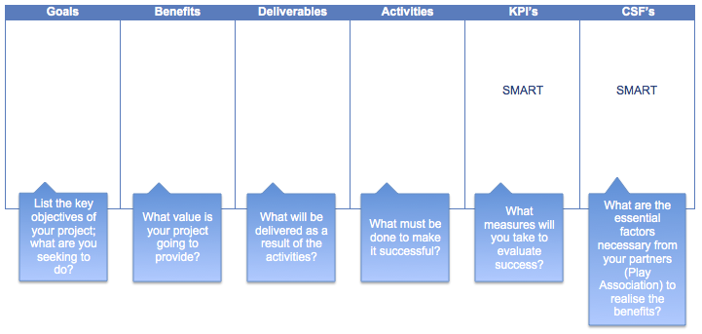
If you require any assistance to completing this template please refer to the online guidance at www.etctoolkit.org.uk
Your completed template should then be sent to direct to Hello@etctoolkit.org.uk for classification. Thank you!

Entrepreneurial How to Guide Business Case Framework QAA 1 4 7
References: Allan, D., Kingdon, M., Murrin, K. and Rudkin, D. (2002) Sticky Wisdom. London: Capstone Publishing Limited.
Senge, P. (2014) Foreward. In Laszlo, C. and Brown, J. Flourishing Enterprise- The New Spirit of Business. California: Stanford University Press.
Authors: Sybille Schiffmann, Futures Entrepreneurship Centre & Plymouth University. Dr Emily Beaumont, Lecturer in Entrepreneurship, Plymouth University.

